

NAME : NITHISH.G

REG NO : 19BCS0012

SUBJECT : DATA STRUCTURE

1. **Largest element in array**

**#include<stdio.h>**

**#include<conio.h>**

**void main()**

**{**

**int a[50],i,n,j,large;**

**printf("enter the size of arrray ");**

**scanf("%d",&n);**

**printf("enter the elements of array");**

**for(i=0;i<n;i++)**

**{**

**scanf("%d",&a[i]);**

**}**

**j=0;**

**large=a[j];**

**for(i=0;i<n;i++)**

**{**

**if(a[i]>a[j])**

**{ j=i;**

**}**

**}**

**printf(" the largest element in array is %d",a[j]);**

**getch();**

**}**

**Out put**

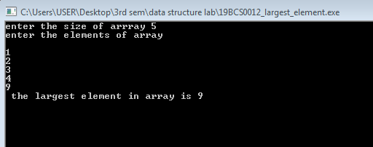

**QNO:2**

**Write a program to find whether the array of integers contains a duplicate number**.

**#include<stdio.h>**

**#include<conio.h>**

**int main()**

**{**

**int a[50],n,i,j,temp;**

**printf("\n enter the number of elements : ");**

**scanf("%d",&n);**

**printf("\n enter the array elements \n");**

**for(i=0;i<n;i++)**

**{**

**scanf("%d",&a[i]);**

**}**

**for(i=0;i<n;i++)**

**{**

**for(j=i+1;j<n;j++)**

**{**

**if(a[i]==a[j])**

**printf(" duplicate values at the location %d and %d \n",i+1,j+1);**

**}**

**}**

**getch();**

**return 0;**

**}**

**Output;**

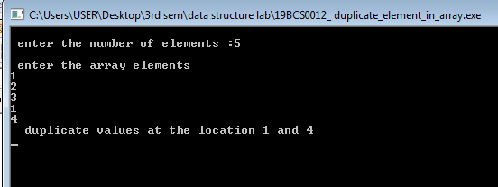

**3. INSERT NEW ELEMENT IN A ARRAY**

**#include<stdio.h>**

**#include<conio.h>**

**main()**

**{**

**int a[10],n,i,l,v,b,temp;**

**printf("\n enter the number of elements :");**

**scanf("%d",&n);**

**printf("\n enter the array elements \n");**

**for(i=0;i<n;i++)**

**{**

**scanf("%d",&a[i]);**

**}**

**printf("\n enter the location where u want to insert the array : ");**

**scanf("%d",&l);**

**printf("\n enter the value to insert : ");**

**scanf("%d",&v);**

**i=n;**

**l=l-1;**

**while(i>=l)**

**{**

**a[i]=a[i-1];**

**i--;**

**}**

**a[l]=v;**

**for(i=0;i<=n;i++)**

**{**

**printf(" \n %d ",a[i]);**

**}**

**getch();**

**return 0;**

**}**

**OUTPUT:**

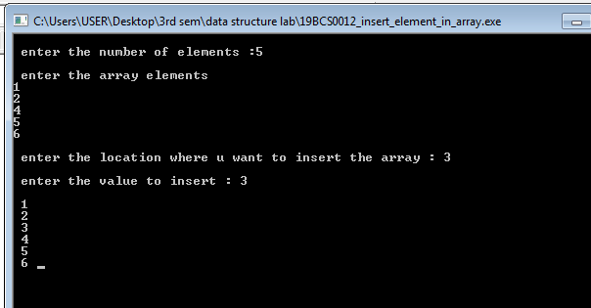

**4. Write a C program to compute the monthly pay of employees. Create a structure named employee with the members’ employee id, employee Name and basic pay Read the no. of employees from the user during runtime. The DA is computed as 52% of the basic pay and gross-salary as basic pay + DA. Print the employees’ id, name, basic pay, DA and gross salary.**

**#include<stdio.h>**

**struct employee**

**{**

**int empid;**

**char empname[100];**

**float basicpay;**

**float da;**

**float grs_sal;**

**};**

**int main()**

**{**

**struct employee e[10];**

**int n,i;**

**printf("\n enter the number of employee : ");**

**scanf("%d",&n);**

**for(i=0;i<n;i++)**

**{**

**printf("\n\n\n\t\t emplyoee no %d : ",i+1);**

**printf("\n\n enter employee id: ");**

**scanf("%d",&e[i].empid);**

**printf("\n enter employee name: ");**

**scanf("%s",&e[i].empname);**

**printf("\n enter employee's basic pay : ");**

**scanf("%f",&e[i].basicpay);**

**e[i].da=(e[i].basicpay/100)*52;**

**e[i].grs_sal= e[i].basicpay + e[i].da;**

**printf("\n\n employee id: %d ",e[i].empid);**

**printf("\n employee name: %s ",e[i].empname);**

**printf("\n employee's basic pay %f ",e[i].basicpay);**

**printf("\n employee DA : %f ",e[i].da);**

**printf("\n employee gross salary : %f ",e[i].grs_sal);**

**}**

**for(i=0;i<n;i++)**

**{**

**printf("\n\n employee id: %d ",e[i].empid);**

**printf("\n employee name: %s ",e[i].empname);**

**printf("\n employee's basic pay %f ",e[i].basicpay);**

**printf("\n employee DA : %f ",e[i].da);**

**printf("\n employee gross salary : %f ",e[i].grs_sal);**

**}**

**getch();**

**return 0;**

**}**

**Output**

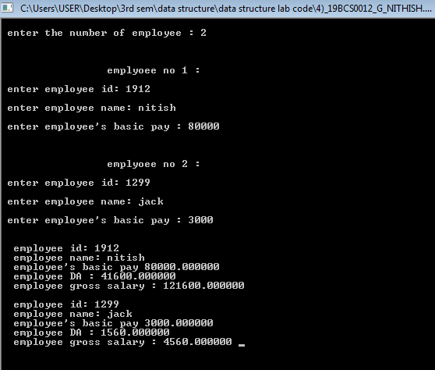

**5. Write a C program that uses functions to perform the following operations:**

* 1. **Reading a complex number.**
  2. **Writing a complex number.**
  3. **Addition and subtraction of two complex numbers.**
  4. **Multiplication of two complex numbers.**

**Note: represent complex number using a structure**

**Source code**

**#include<stdio.h>**

**#include<conio.h>**

**void read();**

**struct complex**

**{**

**int real;**

**int img;**

**void add(int,int);**

**void sub(int,int);**

**void multiplication(int,int);**

**}c1,c2,c3;**

**void add(struct complex c1,struct complex c2)**

**{**

**c3.img=c1.img+c2.img;**

**c3.real=c1.real+c2.real;**

**printf("\n\n Addition of two complex numbers %d + %d i: ",c3.real,c3.img);**

**}**

**void sub(struct complex c1,struct complex c2)**

**{**

**c3.img=c1.img-c2.img;**

**c3.real=c1.real-c2.real;**

**if(c3.img>=0)**

**{**

**printf("\n\n difference of two complex numbers %d + %d i: ",c3.real,c3.img);**

**}**

**else**

**{**

**printf("\n\n difference of two complex numbers %d %d i: ",c3.real,c3.img);**

**}**

**}**

**void multiplication(struct complex c1,struct complex c2)**

**{**

**c3.img=(c1.real*c2.img)+(c1.img*c2.real);**

**c3.real=(c1.real*c2.real)-(c1.img*c2.img);**

**printf("\n\n multiplication of two complex numbers %d * %d i: ",c3.real,c3.img);**

**}**

**int main()**

**{**

**printf("\n enter 1st complex number: ");**

**printf("\n real : ");**

**scanf("%d",&c1.real);**

**printf("\n imaginary : ");**

**scanf("%d",&c1.img);**

**printf("\n\n enter 2st complex number: ");**

**printf("\n real : ");**

**scanf("%d",&c2.real);**

**printf("\n imaginary : ");**

**scanf("%d",&c2.img);**

**add(c1,c2);**

**sub(c1,c2);**

**multiplication(c1,c2);**

**getch();**

**return 0;**

**}**

**Output**

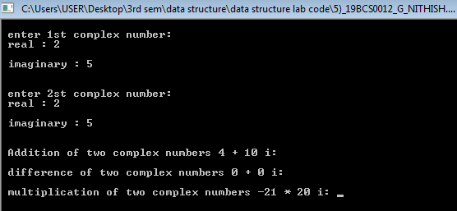

1. **Write a C program to read, display, add, and subtract two distances. Distance must be defined using kms and meters.**

**#include<stdio.h>**

**#include<conio.h>**

**struct distance**

**{**

**int k1,k2;**

**int m1,m2;**

**int t1,t2;**

**} d;**

**int main()**

**{**

**int a;**

**printf("\tEnter the first distance\n");**

**printf("\n\t\tkilometres : ");**

**scanf("%d",&d.k1);**

**printf("\n\t\tmetres : ");**

**scanf("%d",&d.m1);**

**printf("\n\n\tEnter the second distance\n");**

**printf("\n\t\tkilometres : ");**

**scanf("%d",&d.k2);**

**printf("\n\t\tmetres : ");**

**scanf("%d",&d.m2);**

**do**

**{**

**printf("\n\n\tSelect the operation:\n\n1. Addition\n\n2.Subtraction\n\n3. Display\n\n4. Exit\n\n");**

**printf("\n\n\tENTER THE OPPROPRIATE CHOICE : ");**

**scanf("%d",&a);**

**if(a==1)**

**{**

**d.t1=d.k1+d.k2;**

**d.t2=d.m1+d.m2;**

**if(d.t2==1000 || d.t2>1000)**

**{**

**do{**

**d.t2=d.t2-1000;**

**d.t1=d.t1+1;**

**}while(d.t2>1000 || d.t2>=1000);**

**printf("\nAddition : %d Kilometres & %d Metres\n\n\n",d.t1,d.t2);**

**}**

**}**

**else if(a==2)**

**{**

**d.t1=d.k1-d.k2;**

**if(d.m1>d.m2 || d.m1>=d.m2)**

**{**

**d.t2=d.m1-d.m2;**

**if(d.t2>1000 || d.t2 >=1000)**

**{**

**do{**

**d.t2=d.t2-1000;**

**d.t1=d.t1+1;**

**}while(d.t2>1000 || d.t2>=1000);**

**}**

**}**

**else**

**{**

**d.t2=d.m2-d.m1;**

**if(d.t2>1000 || d.t2 >=1000)**

**{**

**do{**

**d.t2=d.t2-1000;**

**d.t1=d.t1+1;**

**}while(d.t2>1000 || d.t2>=1000);**

**}**

**}**

**printf("\nSubtraction : %d Kilometres & %d Metres\n\n",d.t1,d.t2);**

**}**

**else if(a==3)**

**{**

**printf("\n The frist Distances entered by you:\n1. %d Kilometres & %d Metres\n\n",d.k1,d.m1);**

**printf("The second Distances entered by you:\n2. %d Kilometres & %d Metres\n\n",d.k2,d.m2);**

**}**

**else if(a=0)**

**{**

**break;**

**}**

**else**

**{**

**printf("\nNot a valid operation.");**

**}**

**}while(a!=0);**

**getch();**

**return 0;**

**}**

**Output:**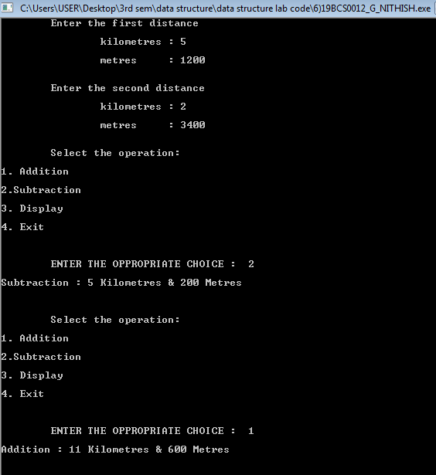

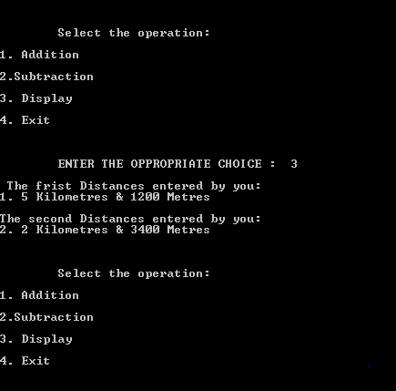

1. **Write a C program to initialize the members of a structure by using a pointer to the structure.**

**Source code**

**#include<stdio.h>**

**#include<conio.h>**

**#include<stdio.h>**

**struct address**

**{**

**char productname[20];**

**char id[40];**

**float quantity;**

**float coast;**

**};**

**int main()**

**{**

**struct address a1,*ptr_a1;**

**ptr_a1=&a1;**

**printf("\nEnter the productname :");**

**scanf("%s",&ptr_a1->productname);**

**printf("\nEnter the id :");**

**scanf("%s",&ptr_a1->id);**

**printf("\n Enter the quantity :");**

**scanf("%f",&ptr_a1->quantity);**

**printf("\nEnter the coast :");**

**scanf("%f",&ptr_a1->coast);**

**printf("\n\n the product name is %s ",ptr_a1->productname);**

**printf(" \n\nthe id is %s ",a1.id);**

**printf(" \n\nthe quantity is %f",a1.quantity);**

**printf("\n\n the total coast is %f ",a1.coast*60);**

**getch();**

**return 0;}**

**Output**

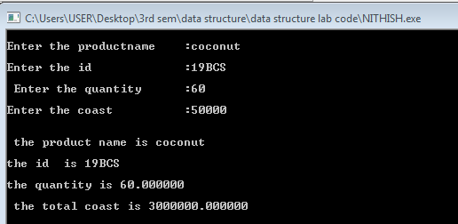

1. **Create a structure named info which contains three array variables m1, m2 and m3 that stores the marks of 5 students. Pass all these marks as arguments to function named calculate using array of pointers. The calculate function should find the class average using the formula:**

**class average= sum of all the marks in one subject/no. of students**

**source code**

**#include<stdio.h>**

**#include<conio.h>**

**void calculate(int *p[]);**

**struct info{**

**int m1[5],m2[5],m3[5];**

**};**

**int main()**

**{**

**struct info s;**

**int i;**

**printf("enter the 5 stundents marks in m1 " );**

**for(i=0;i<5;i++)**

**{**

**scanf("\n%d",&s.m1[i]);**

**}**

**printf("enter the 5 stundents marks in m2 " );**

**for(i=0;i<5;i++)**

**{**

**scanf("\n%d",&s.m2[i]);**

**}**

**printf("enter the 5 stundents marks in m3 " );**

**for(i=0;i<5;i++)**

**{**

**scanf("\n%d",&s.m3[i]);**

**}**

**printf("**************************************************************************");**

**printf("\n\n");**

**int *ptr[]={s.m1,s.m2,s.m3};**

**calculate(ptr);**

**getch();**

**return 0;**

**}**

**void calculate( int *p[])**

**{**

**int i,j;**

**float s1=0,s2=0,s3=0;**

**for(i=0;i<3;i++)**

**{**

**if(i==0)**

**{**

**for(j=0;j<5;j++)**

**{**

**printf(" %d\t",p[i][j] );**

**s1=s1+p[i][j];**

**}**

**s1=s1/j;**

**printf(" \n\nTHIS IS m1 mark of the 5 students\n");**

**printf(" \n\nTHE CLASS AVERAGE OF M1 IS %f\n\n",s1);**

**printf("**************************************************************************");**

**printf("\n\n\n");**

**}**

**else if(i==1)**

**{**

**for(j=0;j<5;j++)**

**{**

**printf(" %d\t",p[i][j] );**

**s2=s2+p[i][j];**

**}**

**s2=s2/j;**

**printf(" \n\nthe m2 mark of the 5 students\n\n");**

**printf(" THE AVERAGE OF THIS M2 IS %f\n",s2);**

**printf("**************************************************************************");**

**printf("\n\n\n");**

**}**

**else if(i==2)**

**{**

**for(j=0;j<5;j++)**

**{**

**printf(" %d\t",p[i][j] );**

**s3=s3+p[i][j];**

**}**

**s3=s3/j;**

**printf(" \n\nthe m3 mark of the 5 students\n\n");**

**printf(" THE AVERAGE OF THIS M3 IS %f\n",s3);**

**printf("**************************************************************************");**

**printf("\n\n\n");**

**}**

**}**

**}**

**Output**

